NOTICE
Subject: Commencement of Classes for May-June 2026 Session.
All students of 2nd, 4th and 6th Semesters are hereby informed that their regular classwork will commence on 09-02-2026. It is mandatory for all students to be punctual and adhere to the class schedule. A minimum attendance of 75% is required for students to be eligible for the final examinations. It is reiterated that wearing the college uniform is compulsory.

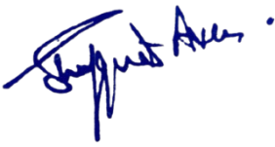

No: No: KGP/Estt/2026/2087
DaaDated:04-02-2026

Principal
Kashmir Government Polytechnic College
Srinagar

Copy to the:
- All concerned for information and compliance.
2. Office File.

